# ChatGPT 4o creates a Chrome extension to find the contextual meaning of words on web pages

[Ken Kahn](mailto:<toontalk@gmail.com>) - [home page](https://docs.google.com/document/d/1r7oaUOGs1TGjtKYo1CCmfqTifH5cqpPny5ALx5EIT_8/edit?usp=sharing)

I started by prompting ChatGPT 4o

I want to make it possible to select a word on a web page in Chrome and then prompt an LLM for its meaning. Any ideas?

It presented a plan and generated the files needed for a Chrome extension with a dummy definition for ‘fetchWordMeaning’. I then pasted the plain text of [the documentation for the forthcoming API for prompting Gemini Nano in Chrome](https://docs.google.com/document/d/1VG8HIyz361zGduWgNG7R_R8Xkv0OOJ8b5C9QKeCjU0c/edit?pli=1) into ChatGPT. My idea is that will run locally and offline. I prompted

The above is the documentation for using an LLM in Chrome. fetchWordMeaning should prompt the LLM with "Respond with a short meaning of the word <the word> in the following: <the sentence containing the word>"

In about thirty minutes it was working. It took two hours to make the final version. This involved

1. Wasting lots of time unsuccessfully trying to replace ‘alert’ with Chrome notifications.
2. Replacing ‘alert’ with a custom popup.
3. Improving how it finds the sentence the selected text is contained in.
4. Destroying prompt sessions after use.

Every line of code was created by ChatGPT.

I tried it on [a BBC article](https://www.bbc.co.uk/news/videos/cy8x3l5weplo). Notice that “dubbed” has 5 different meanings but it explains the appropriate one in the context of the sentence.

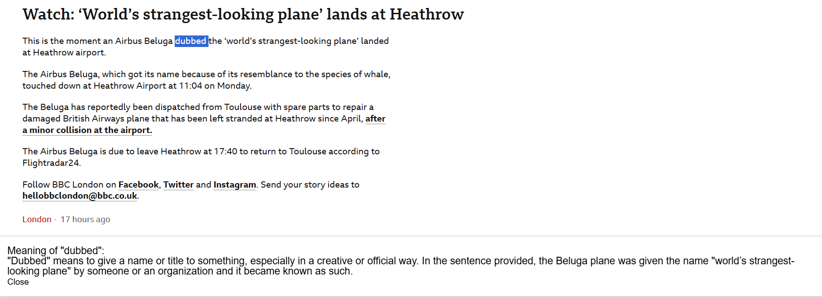

When I right click a word or phrase I then need only click on “Get Meaning of Selected Word”.

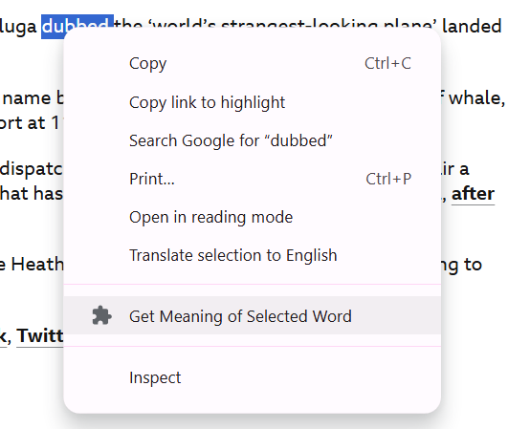

If you want to try it, you’ll need [Gemini Nano in Chrome](https://developer.chrome.com/docs/ai/built-in). Then download and unzip [the extension](https://toontalk.github.io/AI/apps/word-meaning/word%20meaning%20extension.zip). As ChatGPT told me

### **4. Deploy and Test**

* Once you have all the files ready, load the extension in Chrome by going to chrome://extensions/ and clicking "Load unpacked."
* Test by selecting a word, right-clicking, and using the "Get Meaning" context menu option.